Round 1

120 feet

Playground

120 feet

160 feet

Athletic field

360 feet

Round 2

Basketball court

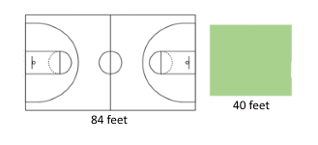

Courtyard

84 feet

40 feet

40 feet

50 feet

50 feet

Round 4

Cubicle A

Cubicle B

12 feet

8 feet

8 feet

8 feet

Round 5

11 feet

Family room

9 feet

Kitchen

12 feet

11 feet

Round 6

25 feet

Garage

25 feet

37 feet

House

70 feet

Round 7

16 inches

18 inches

Waterfall

14 inches

16 inches

Sand dunes

Round 8

25 feet

35 feet

25 feet

Recreation area

Media area

45 feet

Round 9

Garage

House

40 feet

40 feet

24 feet

12 feet

Porch